Chapter 4, Problem 21

Using Fig. 4.89, design a problem to help other students better understand source transformation.
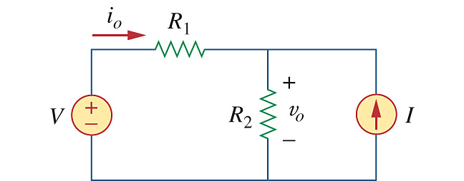

Figure 4.89
For Prob. 4.21.

